Activity #1 for Teaching Workshop
Is teaching just teaching? Are classes and groups different? Do gender-specific or age-graded classes make a difference? Should the types of students in your classes make a difference in both WHAT and HOW you teach? Let’s go to the best source we have, the Bible. Read Titus 2:1-10 in the New International Version and see if you can find what Titus was told to teach those in differing stages of life and situations. [NOTE: It’s better to try to complete these activities BEFORE the workshop, but if you can’t, Pastor Johnny will fill-in the blanks in class.]
- For elder males: ________________, __________________, ____________, __________, ___________, and ___________ (Titus 2:1-2);
- For elder females: ___________, avoiding ________, ____________ responsibly (if at all), teaching ________ and life secrets (Titus 2:3-5);
- For younger females: _________________, _____________, mental & __________ purity, _________________, ______________, and _______________ (Titus 2:4-5);
- For younger males in general: ________________, _______________, ___________________, _________________ (vital) focus, and trustworthy ______________________ (Titus 2:6-8); and
- For slaves (today, all under authority): obedience, pleasant attitude, cooperativeness, honesty, and dependability (Titus 2:9-10).
Activity #2 for Teaching Workshop
Complete the following table using the instructions on the next page.
 | Sunday School |  | Bible Study Group
 | Unintentional attendees
 | Formal cut-off time
 | Information-centered
 | Seems more formal

Although many elements are the same between the two, try to think something that might be different between Sunday School and Bible Study groups and write your idea opposite the description of a Sunday School study in the blank spaces of the diagram shown above. [We will discuss these ideas in the workshop.]
Activity #3 for Teaching Workshop
During the workshop, Pastor Johnny will present the following graph that is totally accepted by some educators, partially accepted by others, and rejected by others. Use the numbered list of ways to learn and retain what one learns and place the number of the way one learns in the blanks provided on the graph below. [We will discuss what’s good and bad about this in the workshop.]
1. Collaboration
2. Doing
3. Hearing
4. Seeing
5. Seeing and Hearing
6. Reading
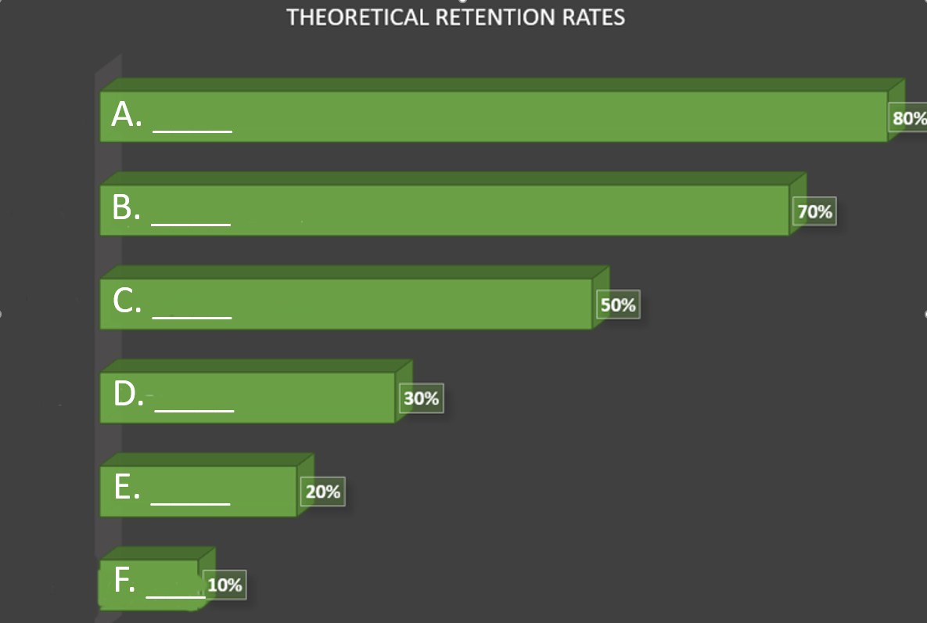
Activity #4 for Teaching Workshop
This is a learning style questionnaire. Please choose a-d for each of the 16 questions below. We will score them together in the first hour of the teaching workshop.
___ 1. You are helping someone who wants to go to your airport or a shopping center. Would you:
a) go with her, b) tell her the directions, c) write own directions without a map, or
d) draw or give her a map.
____2. You aren’t sure whether a word should be spelled “dependent” or “dependant.” You would:
a) see the words in your mind and choose the one that looks right, b) think about how each
word sounds and choose the one that sounds best, c) look it up in a dictionary, or d) write
both words on a piece of paper and choose one.
____3. You’re planning an outing for a group. You want feedback from them about the plan. You would:
a) describe some of the highlights, b) use a map or website to show the places/activities,
c) give them a copy of a printed itinerary/schedule, or d) phone, text, or email them.
____4. You want to cook something as a special treat for your family. You would:
a) cook something you already know without need for a recipe, b) ask friends for suggestions,
c) look through the cookbook for ideas from the pictures, or d) use a cookbook where you
known there would be a good recipe.
____5. A group of tourists want to learn about the parks an nature preserves in your area. You would:
a) talk about, or arrange a talk for them about the parks/preserves, b) show them internet sites,
photographs, or coffee-table books about the parks, c) take them to the closest park or preserve
and walk with them, or d) give them a book or brochure about the parks or preserves.
____6. You’re purchasing digital camera or phone. Other than trying to get the best price, you would:
a) try or test it, b) read details about its features, c) get it if the design looks good, or
d) listen to a salesperson describe its features.
____7. Try to remember a time when you learned how to do something new. Don’t use a physical skill
like riding a bicycle, skating, or shooting baskets. You learned best by:
a) watching a demonstration, b) listening to somebody explaining it and asking questions,
c) examining diagrams, charts, watching YouTube, or d) following written instructions from a manual
or book.
____8. If you have a problem with your knee, would you want the doctor to:
a) give you a web address or something to read about it, b) use a plastic model to demonstrate
what is wrong, c) describe what is wrong, or d) show you a diagram of what’s wrong.
____9. You want to learn a new program or game on your computer (or phone). You would:
a) read the written instructions provided with the program, b) talk with people who know
about the program, c) use the controls or keyboard and see what happens, or d) follow
the diagrams in the documentation or the tutorial.
____10. You like websites that have:
a) things you can click on to shift or try, b) an interesting design and visual features,
c) interesting written descriptions, lists, and explanations, or d) audio channels
where you can hear music, radio programs, or interviews.
____11. Other than price, what would most influence your decision to buy a new non-fiction book?
a) appealing looks, b) quickly scanning parts of it, c) hearing a friend’s recommendation, or
d) noting that it has real-life stories, experiences, and examples.
____12. Assume you are using a book, CD, or website to learn how to take photos with your new
digital camera. You would like to have:
a) a chance to ask questions and talk about the camera and its features,
b) clear written instructions with lists and bullet points about what to do,
c) diagrams showing the camera and what each part does, or
d) many examples of good and poor photos and how to improve them.
____13. Do you prefer a teacher or instructor who uses:
a) demonstrations, models, or practical sessions, b) question and answer, talk,
group discussion, or guest speakers, c) handouts, books, or readings, or
d) diagrams, charts, maps, or graphs.
____14. You just finished a competition or test and would like some feedback. You would
prefer to have that feedback:
a) using examples from what you have one, b) using a written description of your results,
c) from someone who will talk it through with you, or d) using graphs to show what
you have or have not achieved.
____15. You plan to choose some food at a restaurant or café. You would:
a) choose something that you had there once before, b) listen to the waiter or
ask friends to recommend choices, c) choose from the descriptions in the menu, or
d) look at pictures in the menu or what others around you are eating.
____16. If you were giving an important speech at a conference or special occasion. You would:
a) make diagrams or get graphs to explain things, b) write a few key words and
practice saying your speech over an over, c) write out your speech and learn from
reading it over several times, or ) gather many examples an stories to make the talk
real and practical.
As we score this questionnaire together, you will assign a V (Visual), A (Aural), R (Reading/
Writing), or K (Kinesthetic). Knowing your learning style can help you use your strengths,
but it can also aid you in making sure you balance your teaching style to your class’s.
Activity #5 – Planning Your Lesson
In the activity presented on the next page, you will be asked to fill out a form that should help you put together some of what we have considered and apply it to teaching from the Bible. Many of us think that we do some of this automatically, but it helps to follow a checklist once in a while, just like it always helps a pilot to be able to take off successfully. The activity is designed to provide a checklist for planning a study. One form is for your use with Genesis 3, another as your general form, then, Pastor Johnny’s responses to the form if he were teaching Genesis 3.
Scripture Passage for Study: ________________________________
1. What are some of the “big ideas” in the passage?
a) ________________________________________________________________
b) ________________________________________________________________
c) ________________________________________________________________
d) ________________________________________________________________
e) ________________________________________________________________
2. What do the students need to take away from this lesson?
a) ________________________________________________________________
b) ________________________________________________________________
c) ________________________________________________________________
d) ________________________________________________________________
e) ________________________________________________________________
3. What attitudes, skills, actions, or commitments should this lesson encourage?
a) ________________________________________________________________
b) ________________________________________________________________
c) ________________________________________________________________
d) ________________________________________________________________
e) ________________________________________________________________
4, What are my students’/participants’ learning styles?
a) ________________________________________________________________
b) ________________________________________________________________
c) ________________________________________________________________
d) ________________________________________________________________
5. How will I involve students/participants in learning the desired things?
a) ________________________________________________________________
b) ________________________________________________________________
c) ________________________________________________________________
d) ________________________________________________________________
e) ________________________________________________________________

Scripture Passage for Study: ________________________________
1. What are some of the “big ideas” in the passage?
a) ________________________________________________________________
b) ________________________________________________________________
c) ________________________________________________________________
d) ________________________________________________________________
e) ________________________________________________________________
2. What do the students need to take away from this lesson?
a) ________________________________________________________________
b) ________________________________________________________________
c) ________________________________________________________________
d) ________________________________________________________________
e) ________________________________________________________________
3. What attitudes, skills, actions, or commitments should this lesson encourage?
a) ________________________________________________________________
b) ________________________________________________________________
c) ________________________________________________________________
d) ________________________________________________________________
e) ________________________________________________________________
4, What are my students’/participants’ learning styles?
a) ________________________________________________________________
b) ________________________________________________________________
c) ________________________________________________________________
d) ________________________________________________________________
5. How will I involve students/participants in learning the desired things?
a) ________________________________________________________________
b) ________________________________________________________________
c) ________________________________________________________________
d) ________________________________________________________________
e) ________________________________________________________________

Scripture Passage for Study: ________________________________ (Pastor Johnny)
1. What are some of the “big ideas” in the passage? (Genesis 3)
a) ___knowledge isn’t wisdom__ _______________________________________
b) ___temptation questions God, then looks at “appearance,” “need,” “ desire”_
c) ___sin exposes who/what we are, causes fear, separates from God__________
d) ___God takes the initiative, then and now______________________________
e) ___Even God’s punishment provides grace (v. 15 = protoevangelium)________
2. What do the students need to take away from this lesson?
a) ___sneakiness and “reasonableness” of temptation______________________
b) ___the big lie and the big I of sin—not just individual_____________________
c) ___the importance of trusting/obeying God_____________________________
d) ___cost of sin on self and others______________________________________
e) ___God’s plan for negating sin________________________________________
3. What attitudes, skills, actions, or commitments should this lesson encourage?
a) ___awareness / discernment of temptation to sin________________________
b) ___learn to focus on God rather than accepted wisdom___________________
c) ___receive forgiveness______________________________________________
d) ___fellowship with God is better than makeshift solutions_________________
e) ________________________________________________________________
4, What are my students’/participants’ learning styles (in order of strength)?
a) ____visual_______________________________________________________
b) ____kinesthetic___________________________________________________
c) ____aural________________________________________________________
d) ____reading-writing_______________________________________________
5. How will I involve students/participants in learning the desired things?
a) ____images on slides or handouts_(v)___________________________________
b) ____create and explain a collage of advertisements that depict temptation_(v/k)
c) ____give examples of differences between what God says and society says_(a/r)
d) ____dramatize the scene between Eve and the serpent (a/r/k)_______________
e) ____have students share about temptations avoided (a) ____________________

On the next page, you will find a grid with five different ways you might want your students to interact with Scripture, doctrinal studies, ethics, or studies in church history. We will be
providing verbs (each one a learning activity) associated with each type of interaction during the workshop.
Grid for Possible Learning Activities Associated with Scripture, Doctrine, and Ethics

Creativity | Analysis | Understanding | Application | Retention

