Approaches to Outlines of Hebrews
Pastor Johnny’s Symphonic Outline
- Allegro – (1:1-4:13) vibrant, reasonably fast movement to capture attention and point to the rest / powerful first four verses, corrective to angelology, emphasis on salvation, emphasis on “hanging in there”
- Andante – (4:14-6:12) slower pace with emotion / Jesus as great high priest, warning against immaturity and apostasy
- Scherzo – (6:13-10:39) faster, but repetitive majestic pace / emphasis on God’s promises, Christ’s priestly role, warning vs. turning back
- Presto – (11:1-13:19) dance-like reiteration of themes / roll call of faith/trust/faithfulness, applications of those examples
- Coda – (13:20-25) Closing remarks with a challenge as stinger
Pheme Perkins of Boston College’s Emphasis on Exhortation
- Prologue: God has spoken most eloquently in Son (1:1-4)
- The Son’s superiority over the angels (1:5-14)
- Exhortation: Don’t drift away from such a salvation (2:1-4)
- Jesus’ suffering brings humanity to salvation (2:5-18)
- Jesus is greater than Moses (3:1-6)
- Exhortation: Don’t fall away like Israel in wilderness (3:7-4:13)
- Jesus is the sympathetic high priest (4:4-5:10)
- Exhortation: Do not be immature in faith (5:11-6:12)
- God’s promises are confirmed by an oath (6:13-20)
- Jesus is a high priest in the order of Melchizedek (7:1-10:18)
a) Melchizedek represents higher than Levitical priests (7:1-28)
b) Christ’s heavenly sanctuary is better covenant (8:1-13)
c) Christ’s sacrifice makes all sacrifices redundant (9:1-22)
d) Christ’s sacrifice has once-for-all effect (9:23-10:18)
- Exhortation: Hold fast to your faith because there is no sacrifice for turning away from Christ (10:19-39)
- Heroes of faith grasp the reality of heavenly things (11:1-40)
- Exhortation: Persevere following Christ and others (12:1-13:19)
- Letter-like closing (13:20-25)
George H. Guthrie’s Emphasis on the Son (not for the total book, but helpful)
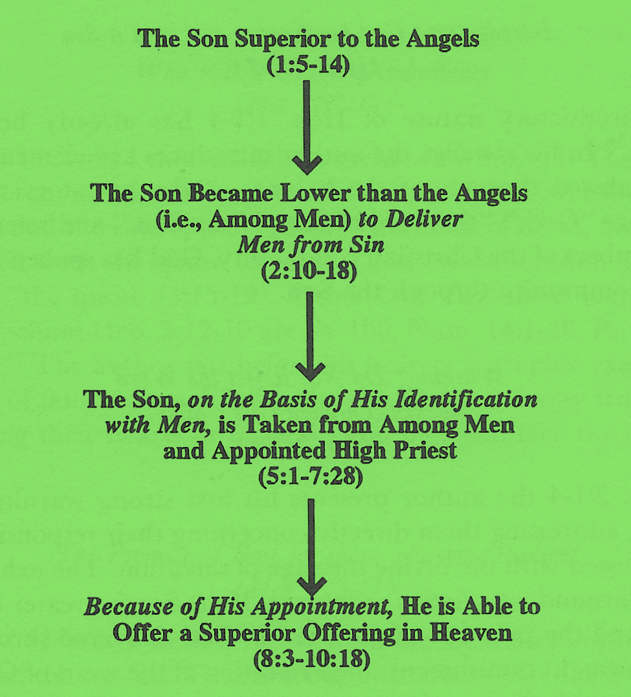
Rafael Gyllenberg’s Five (5) Point Outline of Hebrews
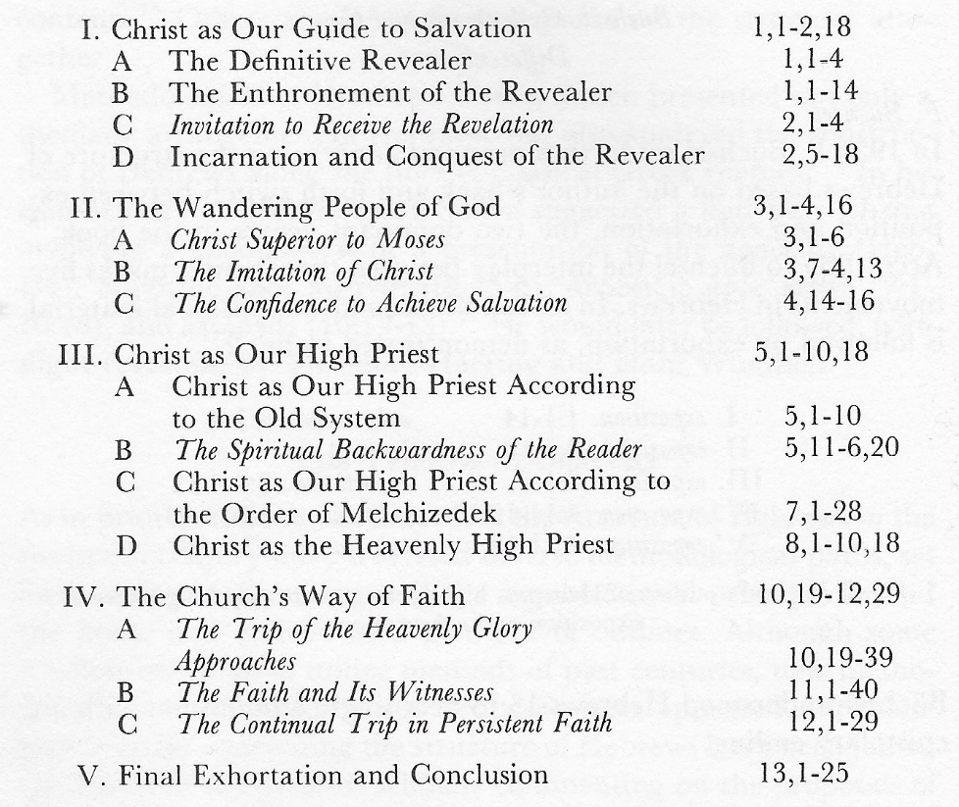
Guthrie’s Catchword Outline
