Preparing to Teach Hebrews – Part IV – Hebrews 5:1-6:20
We closed out last session at the end of Chapter 4 with the concept of Jesus as the perfect, ultimate, complete High Priest. We may not have done enough with those last few verses, but I wasn’t real worried because they lead directly into the next lesson and will continue throughout the book.
Remember, many outlines begin their section with Hebrews 4:13 or 4:14.
[Bruce, F. F. The New International Commentary on the New Testament:
The Epistle to the Hebrews (Grand Rapids, MI: William B. Eerdmans, 1964), p. lxiii.]
III. The High Priesthood of Jesus (4:14-6:20)
1. Christ’s High Priesthood, Encouragement (4:14-16)
2. Qualifications for High Priesthood (5:1-4)
3. Christ’s qualifications (5:5-10)
4. 3rd Admonition: Spiritual Immaturity (5:11-14)
5. No Second Beginning Possible (6:1-8)
6. Encouragement to Persevere (6:9-12)
7. The Steadfastness of God’s Promise (6:13-20)
[DeSilva, David A. Perseverance in Gratitude: A Socio-Rhetorical Commentary on the Epistle “to the Hebrews” (Grand Rapids, MI: William B. Eerdmans, 2000), p. 71.]
4:14-10:18 Central Exposition: Long, Difficult Word
4:14-16 Exhortation: We have a high priest who has
secured and will maintain God’s favor toward
us, so let us draw near to God for sustaining help
5:1-10 Argument: Jesus’ appointment as High Priest
5:11-6:20 Digression (Guide to Gaining God’s Pleasure)
5:11-14 Interruption and appeal for attentive hearing
6:1-3 Exhortation to move forward, not fall away
6:4-8 Those who fall away resent God and God’s gifts
6:9-12 Palliation: We expect YOU to continue your
efforts and are confident of the outcome
6:13-20 WHY we are confident of the outcome: perseverance
[Geisler, Norman L. A Popular Survey of the New Testament (Grand Rapids, MI: Baker Books, 2007), p. 256.]
I. Doctrinal—Christ is Better than Anything Else (Chapters 1-10)
E. Levitical Priests (4:14-7:28)
Trantham, Charles A., “Hebrews” in Clifton J. Allen (ed.), The Broadman Bible
Commentary: Volume 12: Hebrews-Revelation, General Articles
(Nashville: Broadman Press, 1972), p. 13.
III. Our Great High Priest (4:14-5:10)
1. Nature of the High Priest (4:14-16)
2. Qualifications of the High Priest (5:1-10)
a. Human Qualifications (5:1-6)
b. Moral Qualifications (5:7-10)
IV. Application (5:11-6:20)
1. Against sluggishness (5:11-14)
2. Crucifying Christ Again (6:1-12)
3. Reassurance (6:13-20)
a. The Promise (6:13-17)
b. Anchor of Hope (6:18-19)
c. Forerunner and High Priest (6:20)
Perkins, Pheme. Reading the New Testament: An Introduction: Third Edition (Mahwah, NJ: Paulist Press, 2012), p. 250.]
Jesus is the sympathetic high priest (4:14-5:10)
Exhortation: Don’t be Immature in Faith (5:11-6:12)
God’s Promises Confirmed by an Oath (6:13-20)
I also like the connection of key words featured in the diagram in Guthrie, George H. The Structure of Hebrews: A Text-Linguistic Analysis (Grand Rapids, MI: Baker Book House, 1994), p. 94.
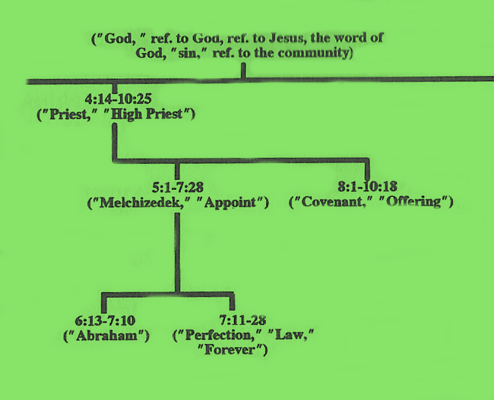
As well as my symphonic approach described in our first session:
- Andante – (4:14-6:12) slower pace with emotion / Jesus as great high priest, warning against immaturity and apostasy
Building on the last part of Chapter 4 where we are given two valuable insights into the nature of Jesus as priest: 1) as the exalted Son of God, Jesus has access to the innermost being of the Father, and 2) as the Incarnate God become human, Jesus isn’t merely a heavenly outsider but someone who has experienced the total human experience—yet without sin.
1) For every high priest is collected out of humankind, appointed on behalf of humankind pertaining to things of God in order to continue offering gifts and sacrifices regarding sins. [PJT]
Note that the continuous perfect is used here, even though a human high priest cannot continuously stand in between humanity and God, but the human high priest could and did offer them at both voluntary (when sinners brought sin offerings) and regular intervals (such as the Day of Atonement). Though the human high priest is collected or taken from the general population, Jesus as High Priest was set aside before the Incarnation. Also, the human high priest offers those sin offerings on behalf of his own sins, as well as those in the congregation. Of course, Hebrews 7:27 tells us that Jesus didn’t have to offer sacrifices for His own sins.
I bring that up because the Greek verb, καθίστημι, meaning to “appoint” or “put one in charge,” doesn’t appear again from this verse until Hebrews 7:28 where it, once again, it’s talking about appointing humans to the priestly role in their weakness. So, we would expect, within this whole section, to see the contrast between human mediators and Jesus as the ultimate Mediator. This is also important because 5:6 refers to the order of Melchizedek to show the difference between Jesus and the merely human high priests and 6:20-7:17 where we are shown the superiority of the order of Melchizedek over the Levitical priests. We’ll deal with Melchizedek more in the next session, but we won’t forget him in this session.
I also bring it up because Hebrews 5:10 uses a different verb, προσαγορεύω, meaning to name or to designate, when Jesus is selected as High Priest. The human high priests are selected from among humanity but Jesus is “designated” by God Himself as High Priest. I use the comparison between a baseball pinch hitter that bats and either leaves the game to substitutes so that someone else does, Again, the human priests come from the Levites, but Jesus comes from this mysterious Melchizedek. 10) He was designated high priest by God, according to the order of Melchizedek. [PJT]
So, before we deal with Melchizedek, let’s see what the last part of Hebrews 4 and the first part of Hebrews 5 have to say about the differences between Jesus and human high priests. I suggest that you divide a whiteboard into two columns and lead the class to fill out the following diagram from their Bibles. [HINT: You could help them by just writing the scripture references shown on my chart and having them look them up to fill in the comparison.] When we get to Hebrews 7, we’ll make this chart larger.
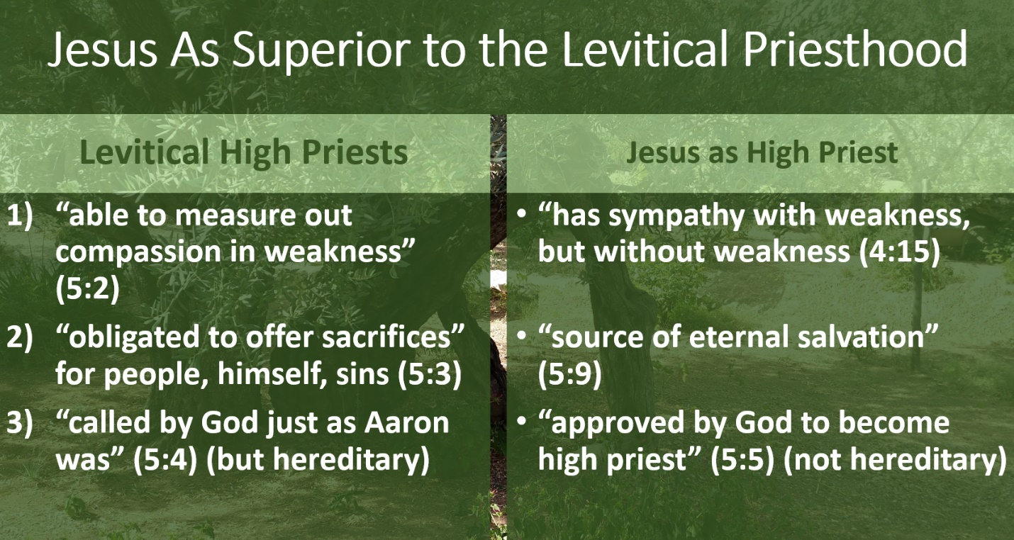

So, let’s grapple with the idea of Melchizedek. Some people believe that Melchizedek was a pre-incarnate appearance of Jesus. You might ask students to agree or disagree with that idea. Tell them that the name, Melchizedek, comes from the Hebrew word for king (pronounced “meh-lehk”) and the Hebrew word for righteousness (pronounced “tseh-deh-kah”). So, his name means “King of Righteousness” and seems to be Jesus’ name. And in Genesis 14:18, Melchizedek is called the “King of Salem” in which the word “Salem” comes from the Hebrew word for peace (pronounced “shah-lohm”). Who else would be the “King of Peace” other than Jesus?
However, pay attention to the wording in Hebrews 7:11 that calls out for “another priest” from the order of Melchizedek. If Melchizedek is Jesus, why would Hebrews treat him as “another priest?” And, look at Hebrews 7:15 where “another priest” is in the “likeness,” not identical to Melchizedek.
But, it is safe to say that Melchizedek is a figure that points toward Jesus. He is in a position superior to Abraham. He is both a priest AND a king. He is a priest of the Highest God and receives Abram’s tithe. His ancestry is not straightforward. He appears at a critical time and disappears after providing a blessing for Abram.
Here’s why Melchizedek is important in Hebrews 5. First, it quotes Psalm 2:7. You might have the students look at Psalm 2:6-7 to see that kingship and the idea of a son of god (in the crowned King of Israel’s case) and Son of God in Jesus’ case go together. The Jews had an idealistic notion of the Messiah as Priest-King, just like Melchizedek was a priest-king. This is the context of Hebrews 5:5 which quotes Psalm 2:7. Then, have the students look at Psalm 110:1-2. Once again it is talking about a king. But Hebrews 5:6 quotes Psalm 110:4 and ties the king to Melchizedek.
As an aside, Jesus also quoted Psalm 110 in Mark 12:35-37. He knew that the Jewish leaders would emphasize that Jesus’ parents may be from the lineage of David, but that they weren’t significant powers in their extended family. So, He confounded them and pleased the crowd by pointing out that the Messiah needed to be Son of God more than Son of David. But He didn’t claim to be the Messiah at this point. Although He uses Psalm 110 along with Daniel 7 to claim Messianic authority in Mark 14:62.
Hebrews 5 also doesn’t leave all of Christology to knowing Jesus as the Son. It doesn’t play around with a Jesus Who wouldn’t face real temptations that humans experience. So, I translate Hebrews 5:7-9 as follows: 7) Who, in the days of His physical body offered prayers and pleas with loud cries and tears to the One able to rescue Him from death, and He was heard from His authentic fear.
8) Even though He was a Son, He learned obedience from what He suffered
9) And became complete, becoming the source of eternal salvation to all who obey Him.
(Hebrews 5:7-9 PJT)
This doesn’t happen on the cross. On the cross, He has a mission, and He expresses it. It must refer to Gethsemane. And it is a much more powerful vision of Jesus’ prayer than we see in the gospels. Some translations end verse 7 with “godly fear” or “reverence.” Neither gives sufficient attention to what Oscar Cullman noted in his Christology of the New Testament. “It can just as accurately be translated, ‘He was heard in his fear (anxiety). The whole context forces upon one the sense of ordinary human fear….This is just what the temptation is.” And he goes on to explain: “Jesus was really a man, not just God disguised as a man.” [Cullman, Oscar. The Christology of the New Testament (Philadelphia, PA: The Westminster Press, 1963), p. 96.] He summarizes what he means on p. 97: “Hebrews is not so much interested in Jesus’ becoming man as in his being man.”
My favorite theologian, Wolfhart Pannenberg, makes similar statements, but he is concerned that readers of verse 8 might confuse this idea of Jesus “learning obedience” with the perfect relationship He already had with the Father in the Trinity. Remember that Jesus willingly limited Himself to experience all that is human, but without sin. Pannenberg goes on to assert: “At any rate, the status of sonship and obedience to the Father go together. Obedient subordination to the Father characterizes Jesus as the Son. As Paul puts it, he lets himself be guided by the Spirit of God (Romans 8:14). His obedience, then, is not the alien obedience of the slave. It is an expression of his free agreement with the Father. By this Spirit, he has in himself the eternal life that shows him to be the living and incorruptible Christ in his resurrection from the dead.” [Pannenberg, Wolfhart. Systematic Theology: Volume 2 (Grand Rapids, MI: William B. Eerdmans, 1994), p. 316.]
As for the critique of the audience to which the book is written, the comparison of milk to solid food would have been familiar. Not only did Paul use the metaphor in 1 Corinthians 3:2 but philosophers such as Philo used it. It is a warning against complacency and against the easy understanding of God’s Word. It can be interesting to use the divided whiteboard approach again and ask students what they believe would be milk and what would be solid food. Point out that this is speculation, since the author of Hebrews wants them to build on Jesus as High Priest, Son of God, and King. What would each of those three mean for practical Christianity.
But Hebrews 6:1-3 makes it clear that the author doesn’t want his or her hearers to be satisfied with those basics. He wants them to grow, to mature, to persevere. I love that root idea of being “driven like the wind” toward the end, the goal, the finish line. I particularly like it because we have a mighty wind powering us in the Holy Spirit. We are “powered” toward a “purpose.” In fact, you can find the answers to the “milk” column in Hebrews 6:1-2. Does that mean we forget them? No, but it means they aren’t enough. It even means that dwelling on them can anchor us when we need to be sailing forward with God’s power and purpose.
The time in which Hebrews was written was a time of great persecution. Both for the sake of Roman crackdowns and Jewish violence, there was a temptation for people who had aligned themselves with the church to make a public denial of Christ and disassociate themselves from fellowship. When one does this, one makes oneself less and less likely to “hear” the inner voice of the Holy Spirit convicting one of sin. As with the idea of “hardening one’s heart” with the Pharaoh in Exodus and with the idea of the unpardonable sin in Matthew 12:32, this is not something that happens all at once. Denial of the lifestyle with Christ requires living a lifestyle in denial.
I like what Karen H. Joines of Wheaton University wrote: “This may be perhaps because they have believed just enough, just long enough to be inoculated, so to speak, against the gospel, and tragically will never again desire to be reconciled to God in Christ.” [Jobes, Karen H., Letters to the Church: A Survey of Hebrews and the General Epistles (Grand Rapids, MI: Zondervan Academic, 2011), p. 140.] It is NOT “falling down,” it is deliberately removing oneself from listening the positive influence of God or “falling away” from fellowship and “falling out” of the Christian journey.
Palliation: But that’s not YOU! Don’t get sluggish, be imitators of faith, inherit the promises.
Take the example of Abraham. When did Abraham receive the promise? Notice “patiently endured” in v. 15. The verb literally means “long spirit” and is translated as “longsuffering” in other parts of the Bible. The point of this final section of Chapter 6 is to emphasize that just as the Jews take courage/comfort/inspiration from Abraham’s endurance in order to receive the promises of God, so should we who trust in Jesus as the Christ be willing to endure much as we await the fulfillment of God’s promises to us.
Franz Delitzsch sees these verses as being strictly related to God’s promise (taking an oath on Himself) at Mount Moriah after the near-sacrifice (“intent” to sacrifice) Isaac (Genesis 22:16-18) because of the partial quotation, “Surely blessing I will bless thee, and multiplying I will multiply thee.” Delitzsch emphasizes this incident because it is the first time in scripture that God takes on oath on Himself, because, of course, there would be nothing higher to base one’s promise upon.
I believe it is just as valid to suggest that God’s promises from the beginning with His call to Abram/Abraham required a long, intense journey with frequent loss in order to obtain God’s promise. I make this distinction because Genesis 22 is so late in the Abraham narrative that lengthy endurance thereafter doesn’t make a lot of sense. What does make sense is what Delitzsch wrote about the verse in Hebrews: “The author’s purpose is in the first place to show, by Abraham’s example, how surely faith and patience will find their reward—how certain they are to obtain the promises; and in the next place to remind his readers on what a strong foundation their Christian hope, as formerly that of Abraham, is now established.” [Delitzsch, Franz, Delitzsch’s Commentary on the Hebrews: Volume 1 (Edinburgh: T & T Clark, 1868), p. 305.]
And that, leads us of course, to the anchor metaphor. In Christ, our hope is greater than that of the Old Covenant: “Using the simile of an ‘anchor’ to convey the significance of the believers’ ‘hope’ invites the addressees to regard the assurance of a heavenly homeland as the fixed point in their lives, as that which keeps them from ‘drifting’ into danger (cf. 2:1-4), their source of stability in a storm—perhaps specifically the squall of cognitive dissonance, of living as children of God and as dispossessed and disenfranchised persons at the same time.” [DeSilva, David A., Perseverance in Gratitude: A Socio-Rhetorical Commentary on the Epistle “to the Hebrews” (Grand Rapids, MI: William B. Eerdmans, 2000), p. 251.]
If, as some interpreters argue, the contrast between the heavenly and the earthly is because the earthly temple has already been destroyed in A.D. 70, think about how the idea of the earthly being only a shadow or a “model” of the heavenly throne/altar of God would further emphasize this lesson to which Delitzsch and DeSilva, more than a century apart, point. The examples in Hebrews are constantly pointing to how much better off the Christian’s hope is than those trusting in the Old Covenant. While one fades away in importance, the other grows ever stronger and clearer in importance. If those prior to God’s revelation in Christ could persevere with such endurance, how much more should we persevere?

